Children’s Dictionary

What is Children’s Dictionary
# Source: AI Source: Provided by: [Data Path: Persons Table -> ID Column: 1, Name_En Column: Motasem Essam] -> From: [Chatgpt (GPT-4-turbo)] on [7/29/2025]
A Children’s Dictionary is specially designed for young users, typically between the ages of 5 and 12. It provides age-appropriate vocabulary, simplified definitions, and often colorful illustrations to support early reading, comprehension, and language development.

🔹 Key Features of a Children’s Dictionary
# Source: AI Source: Provided by: [Data Path: Persons Table -> ID Column: 1, Name_En Column: Motasem Essam] -> From: [Chatgpt (GPT-4-turbo)] on [7/29/2025]
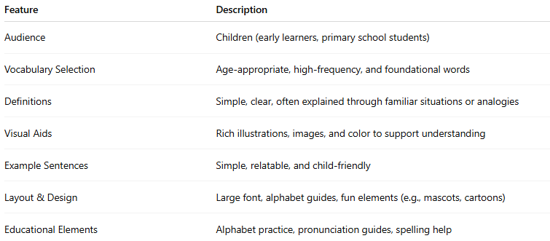
Feature | Description
Audience | Children (early learners, primary school students)
Vocabulary Selection | Age-appropriate, high-frequency, and foundational words
Definitions | Simple, clear, often explained through familiar situations or analogies
Visual Aids | Rich illustrations, images, and color to support understanding
Example Sentences | Simple, relatable, and child-friendly
Layout & Design | Large font, alphabet guides, fun elements (e.g., mascots, cartoons)
Educational Elements | Alphabet practice, pronunciation guides, spelling help

🔹 Examples of Children’s Dictionaries
# Source: AI Source: Provided by: [Data Path: Persons Table -> ID Column: 1, Name_En Column: Motasem Essam] -> From: [Chatgpt (GPT-4-turbo)] on [7/29/2025]
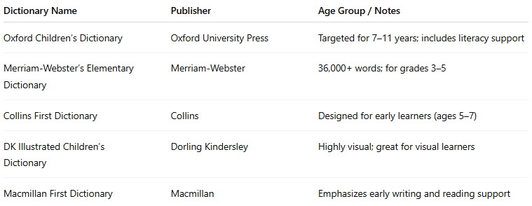
Dictionary Name | Publisher | Age Group / Notes
Oxford Children’s Dictionary | Oxford University Press | Targeted for 7–11 years; includes literacy support
Merriam-Webster’s Elementary Dictionary | Merriam-Webster | 36,000+ words; for grades 3–5
Collins First Dictionary | Collins | Designed for early learners (ages 5–7)
DK Illustrated Children’s Dictionary | Dorling Kindersley | Highly visual; great for visual learners
Macmillan First Dictionary | Macmillan | Emphasizes early writing and reading support

🔹 Advantages
# Source: AI Source: Provided by: [Data Path: Persons Table -> ID Column: 1, Name_En Column: Motasem Essam] -> From: [Chatgpt (GPT-4-turbo)] on [7/29/2025]
- Encourages early vocabulary acquisition
- Supports reading development and spelling
- Engages children with color, visuals, and fun examples
- Builds a foundation for lifelong language learning

🔹 Use Cases
# Source: AI Source: Provided by: [Data Path: Persons Table -> ID Column: 1, Name_En Column: Motasem Essam] -> From: [Chatgpt (GPT-4-turbo)] on [7/29/2025]
- Primary education classrooms
- At-home language development
- ESL/EFL young learners
- Children’s reading programs and libraries

